LETSDEFEND LAB WRITEUP 04 / 06

SIEM 101
  - Course-level learning summary, backed by supplied screenshot

Learning focus
A SIEM centralizes events, normalizes fields and generates detections for analysts.

Key concepts covered
- Recognize collection, parsing, correlation and dashboard workflow.
- Understand detection rules and alert fatigue.
- Use incident context to distinguish false positives.

How a SOC analyst would use these skills
- Preserve incident context (time, affected user/host, evidence, and severity).
- Correlate endpoint and network alerts with relevant log source records.
- Explain next steps and avoid marking an event malicious without validation.

Provided evidence and limitation
Learner reports completing this free course. The screenshot supplied in Week 3 ZIP shows the training page; it does not by itself prove every sub-question or hands-on action. No individual quiz answers are invented here.
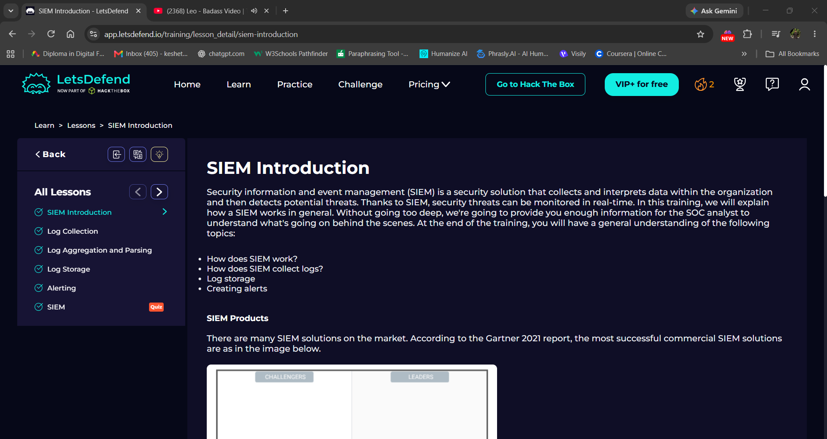
Evidence: LetsDefend training screenshot – SIEM 101

Reflection
I connected this course to the practical Week 3 tasks: Sysmon for Windows endpoint events, auditd for Linux commands and Snort for network detection. This is a course-level reflection, not an unverified transcript of every lesson.

